# B.M.S. COLLEGE OF ENGINEERING

(Autonomous College Affiliated to Visvesvaraya Technological University, Belgaum) Bull Temple Road, Basavanagudi, Bengaluru – 560019



**LAB REPORT**

On

***Object Oriented Java Programming***

**(23CS3PCOOJ)**

Submitted By :

**Tarun M M**

**1BM22CS306**

*In partial fulfilment of*

**BACHELOR OF ENGINEERING**

In

**COMPUTER SCIENCE AND ENGINEERING**

2023-24

# B.M.S. COLLEGE OF ENGINEERING

(Autonomous College Affiliated to Visvesvaraya Technological University, Belgaum) Bull Temple Road, Basavanagudi, Bengaluru – 560019



**Department of**

**Computer Science & Engineering (CSE)**

CERTIFICATE

This is to certify that the Lab work entitled “Object Oriented Programming in Java (22CS3PCOOJ)” conducted by **Tarun MM (1BM22CS306),** who is bonafide student at **B.M.S.College of Engineering**. It is in partial fulfilment for the award of **Bachelor of Engineering in Computer Science and Engineering** during the academic year 2023-24. The Lab report has been approved as it satisfies the academic requirements in respect of Object Oriented Programming in Java (22CS3PCOOJ) work prescribed for the said degree.

**Tarun MM Shravya AR**

1BM22CS306 Assistant Professor

Department of CSE

BMSCE, Bengaluru-19

# Table of contents

|  |  |  |
| --- | --- | --- |
| **Sl.**  **No.** | **Program Title** | **Page No.** |
| 1 | The solution to the Quadratic equation | 4-5 |
| 2 | Student details and Percentage calculation | 5-7 |
| 3 | Book Details | 8-9 |
| 4 | Calculating the Area of Different Shapes | 10-11 |
| 5 | Bank Details | 12-15 |
| 6 | CIE and SEE marks details(PACKAGES) | 15-19 |
| 7 | Exception Handling | 19-21 |
| 8 | Threads | 21-22 |
| 9 | Working with AWT | 23- 24 |

PROGRAM 1:

Develop a Java program that prints all real solutions to the quadratic equation

ax2 +bx+c = 0. Read in a, b, c and use the quadratic formula. If the discriminate b 2 -4ac

is negative, display a message stating that there are no real solutions.

import java.util.Scanner;

import java.lang.Math;

class quadratic

{

public static void main(String agrs[])

 {

System.out.println("Name: Tarun M M");

System.out.println("USN: 1BM22CS306");

    int a,b,c;

    System.out.println("enter the values of a,b,c respectively\n");

    Scanner s1= new Scanner(System.in);

    a = s1.nextInt();

    b = s1.nextInt();

    c = s1.nextInt();

    double d= b*b - 4*a*c ;

    System.out.println("a = " + a +" b = " + b +" c = " + c);

    if(a==0) {System.out.println("not a quadratic equation");}

    else if( d>0)

    {

      System.out.println("the equation has two real and different solutions");

      double r1=(-b + Math.sqrt(d))/(2*a);

      double r2=(-b - Math.sqrt(d))/(2*a);

      System.out.println("r1 = " + r1);

      System.out.println("r2 = " + r2);

    }

   else if(d==0)

    {

      System.out.println("the equation has real and equal solutions");

      double r1= -b/(2*a);

      double r2= -b/(2*a);

      System.out.println("r1 = " + r1);

      System.out.println("r2 = " + r2);

    }

   else if(d<0)

    {

     System.out.println("the equation has unreal solutions");

    }

 }

}

OUTPUT:

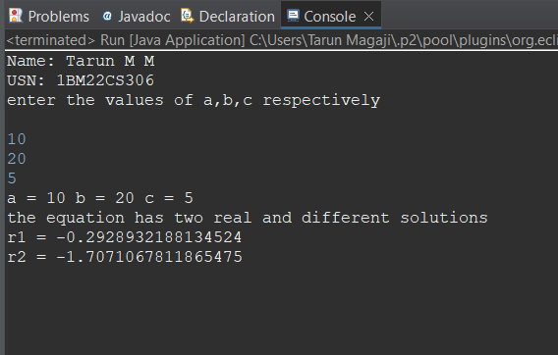

PROGRAM 2:

Develop a Java program to create a class Student with members usn, name, an array

credits and an array marks. Include methods to accept and display details and a

method to calculate percentage of a student.

import java.util.Scanner;  
class Student{  
   String usn;  
   String name;  
   int marks[]= new int[6];  
     
   void Details()  
   {  
Scanner s=new Scanner(System.in);  
System.out.println("Enter USN");  
usn=s.next();  
System.out.println("Enter Name");  
name=s.next();  
System.out.println("Enter marks for 6 subjects:");  
for(int i = 0; i < 6; i++)  
{  
System.out.print("Subject " + (i + 1) + ": ");  
marks[i]=s.nextInt();  
}  
   }  
   double percentage()  
   {  
int total=0;  
for(int i=0;i<6;i++)  
{  
total+=marks[i];  
}  
double p=total/6;  
return p;  
   }  
   void display()  
   {  
System.out.println("\nStudent Details:");  
        System.out.println("USN: " + usn);  
        System.out.println("Name: " + name);  
        System.out.println("Marks:");  
        for(int i = 0; i < 6; i++)  
        {  
System.out.println("Subject " + (i + 1) + ": " + marks[i]);  
        }  
        System.out.println("Percentage: "+ percentage() + "%");  
   }  
}  
class Lab1student  
{  
public static void main(String args[]){  
Scanner s = new Scanner(System.in);

System.out.println("Name: Tarun M M");

System.out.println("USN: 1BM22CS306");  
System.out.print("Enter the number of students: ");  
int n = s.nextInt();  
Student[] students = new Student[n];  
for (int i = 0; i < n; i++)  
{  
students[i] = new Student();  
System.out.println("\nEnter details for Student " + (i + 1) + ":");  
students[i].Details();  
}  
for (Student student : students)  
{  
student.display();  
}  
}  
}

OUTPUT:

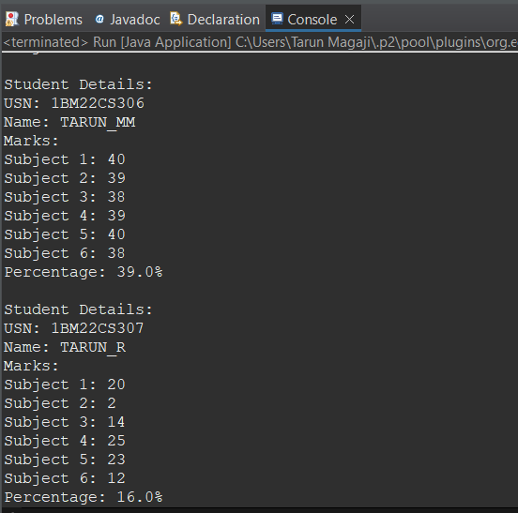

PROGRAM 3:

Create a class Book which contains four members: name, author, price, num_pages.

Include a constructor to set the values for the members. Include methods to set and

get the details of the objects. Include a toString( ) method that could display the

complete details of the book. Develop a Java program to create n book objects.

import java.util.Scanner;

class Books {

    String Name;

    String Author;

    int price;

    int numPages;

    Books(String Name, String Author, int price, int numPages) {

        this.Name = Name;

        this.Author = Author;

        this.numPages = numPages;

        this.price = price;

    }

    public String toString() {

        String name, Author, price, numPages;

        name = "Book name: " + this.Name + "\n";

        Author = "Author name: " + this.Author + "\n";

        numPages = "Number of pages: " + this.numPages + "\n";

        price = "Price: " + this.price + "\n";

        return name + Author + numPages + price;

    }

}

class Main {

    public static void main(String[] args) {

        Scanner s = new Scanner(System.in);

        int n;

        String Name;

        String Author;

        int price;

        int numPages;

System.out.println("Name: Tarun M M");

System.out.println("USN: 1BM22CS306");

        System.out.println("Enter the number of books");

        n = s.nextInt();

        Books b[] = new Books[n];

        for (int i = 0; i < n; i++) {

            System.out.println("book");

            System.out.println("Enter name of book");

            Name = s.next();

            System.out.println("Enter name of Author");

            Author = s.next();

            System.out.println("Enter price");

            price = s.nextInt();

            System.out.println("Enter numPages");

            numPages = s.nextInt();

            b[i] = new Books(Name, Author, price, numPages);

        }

        for (int i = 0; i < n; i++) {

            System.out.println("Books " + (i + 1) + "\n");

            System.out.println(b[i].toString());

        }

    }

}

OUTPUT:

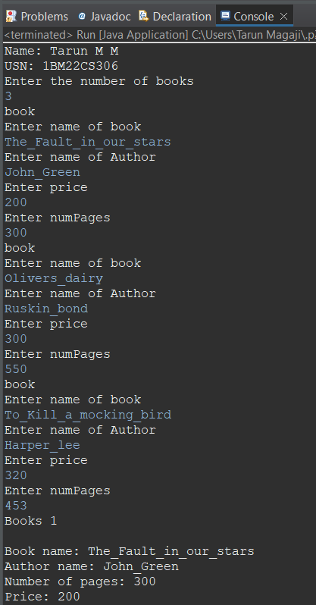

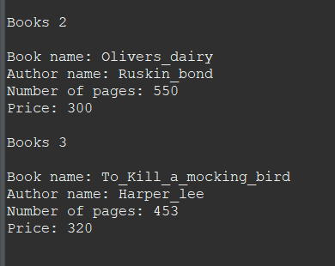

PROGRAM 4:

Develop a Java program to create an abstract class named Shape that contains two

integers and an empty method named printArea( ). Provide three classes named

Rectangle, Triangle and Circle such that each one of the classes extends the class

Shape. Each one of the classes contain only the method printArea( ) that prints the

area of the given shape.

abstract class Shape {

protected int dimension1;

protected int dimension2;

public Shape(int dimension1, int dimension2) {

this.dimension1 = dimension1;

this.dimension2 = dimension2;

}

public abstract void printArea();

}

class Rectangle extends Shape {

public Rectangle(int length, int width) {

super(length, width);

}

public void printArea() {

int area = dimension1 * dimension2;

System.out.println("Area of Rectangle: " + area);

}

}

class Triangle extends Shape {

public Triangle(int base, int height) {

super(base, height);

}

public void printArea() {

double area = 0.5 * dimension1 * dimension2;

System.out.println("Area of Triangle: "+ area);

}

}

class Circle extends Shape {

public Circle(int radius) {

super(radius, 0);

}

public void printArea() {

double area = 3.14* dimension1 * dimension1;

System.out.println("Area of Circle: " + area);

}

}

public class Main1 {

public static void main(String[] args) {

System.out.println("Name: Tarun MM");

System.out.println("USN: 1BM22CS306");

Rectangle rectangle = new Rectangle(4, 5);

rectangle.printArea();

Triangle triangle = new Triangle(3, 6);

triangle.printArea();

Circle circle = new Circle(7);

circle.printArea();

}

}

OUTPUT:

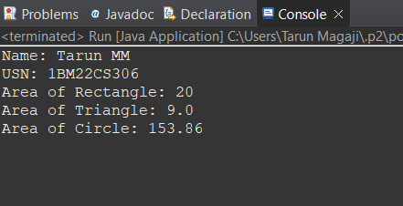

PROGRAM 5:

Develop a Java program to create a class Bank that maintains two kinds of account

for its customers, one called savings account and the other current account. The

savings account provides compound interest and withdrawal facilities but no cheque

book facility. The current account provides cheque book facility but no interest.

Current account holders should also maintain a minimum balance and if the balance

falls below this level, a service charge is imposed.

Create a class Account that stores customer name, account number and type of

account. From this derive the classes Cur-acct and Sav-acct to make them more

specific to their requirements. Include the necessary methods in order to achieve the

following tasks:

a) Accept deposit from customer and update the balance.

b) Display the balance.

c) Compute and deposit interest

d) Permit withdrawal and update the balance

Check for the minimum balance, impose penalty if necessary and update the balance.

class Bank {

public static void main(String[] args) {

SavingsAccount savingsAccount = new SavingsAccount(&quot;John Doe&quot;, &quot;SA1001&quot;);

CurrentAccount currentAccount = new CurrentAccount(&quot;Jane Smith&quot;, &quot;CA2002&quot;);

// Perform operations on savings account

savingsAccount.deposit(5000);

savingsAccount.displayBalance();

savingsAccount.computeInterest();

savingsAccount.displayBalance();

savingsAccount.withdraw(2000);

savingsAccount.displayBalance();

currentAccount.deposit(8000);

currentAccount.displayBalance();

currentAccount.withdraw(5000);

currentAccount.displayBalance();

}

}

class Account {

protected String customerName;

protected String accountNumber;

protected double balance;

public Account(String customerName, String accountNumber) {

this.customerName = customerName;

this.accountNumber = accountNumber;

this.balance = 0;

}

public void deposit(double amount) {

balance += amount;

System.out.println("Deposit of " + amount + "successful");

}

public void displayBalance() {

System.out.println("Account Number"+ accountNumber + "\nBalance: "+ balance);

}

}

class SavingsAccount extends Account {

public SavingsAccount(String customerName, String accountNumber) {

super(customerName, accountNumber);

}

public void computeInterest() {

double interestRate = 0.05;

double interest = balance * interestRate;

balance += interest;

System.out.println("Interest of "+ interest + "computed and added to the balance. ");

}

public void withdraw(double amount) {

if (balance >= amount) {

balance -= amount;

System.out.println("Withdrawal of " + amount + "successful");

} else {

System.out.println("Insufficient funds for withdrawal");

}

}

}

class CurrentAccount extends Account {

private double minimumBalance = 1000;

public CurrentAccount(String customerName, String accountNumber) {

super(customerName, accountNumber);

}

public void withdraw(double amount) {

if (balance - amount >= minimumBalance) {

balance -= amount;

System.out.println("Withdrawal of "+ amount + "successful. ");

} else {

System.out.println("Insufficient funds. Service charge applied");

imposeServiceCharge();

}

}

private void imposeServiceCharge() {

double serviceCharge = 20;

balance -= serviceCharge;

System.out.println("Service charge of " + serviceCharge + " imposed. ");

}

}

OUTPUT:

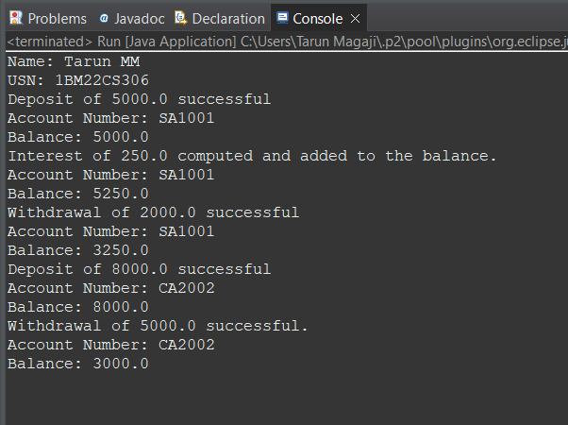

PROGRAM 6:

Create a package CIE which has two classes- Student and Internals. The class Personal

has members like usn, name, sem. The class internals has an array that stores the

internal marks scored in five courses of the current semester of the student. Create

another package SEE which has the class External which is a derived class of Student.

This class has an array that stores the SEE marks scored in five courses of the current

semester of the student. Import the two packages in a file that declares the final

marks of n students in all five courses.

Cie folder:

Internals:

package cie;

public class Internals extends Student{

public int[] marks=new int[5];

}

Student:

package cie;

public class Student{

public String name;

public String usn;

public int sem;

}

See folder:

package see;

import cie.Student;

public class External extends Student{

public int[] seemarks=new int[5];

}

Main :

import cie.Internals;

import see.External;

import java.util.Scanner;

public class Main {

public static void main(String[] args) {

System.out.println("Name:Tarun MM");

System.out.println("USN:1BM22CS306");

System.out.println("Enter the number of students");

Scanner input = new Scanner(System.in);

int n = input.nextInt();

Internals[] s1 = new Internals[n];

External[] s2 = new External[n];

int[] finalcie = new int[n];

int[] finalsee = new int[n];

for (int i = 0; i < n; i++) {

s1[i] = new Internals();

System.out.println("Enter the name");

s1[i].name = input.next();

System.out.println("Enter the usn");

s1[i].usn = input.next();

System.out.println("Enter the sem");

s1[i].sem = input.nextInt();

System.out.println("Enter the marks of 5 subjects");

for (int j = 0; j < 5; j++) {

s1[i].marks[j] = input.nextInt();

finalcie[i] += s1[i].marks[j];

}

}

for (int i = 0; i < n; i++) {

s2[i] = new External();

System.out.println("Enter the name");

s2[i].name = input.next();

System.out.println("Enter the usn");

s2[i].usn = input.next();

System.out.println("Enter the sem");

s2[i].sem = input.nextInt();

System.out.println("Enter the marks of 5 subjects");

for (int j = 0; j < 5; j++) {

s2[i].seemarks[j] = input.nextInt();

finalsee[i] += s2[i].seemarks[j];

}

}

System.out.println("Final marks:");

for (int i = 0; i < n; i++) {

System.out.println("Name: " + s1[i].name + " USN: " + s1[i].usn + " Sem: " + s1[i].sem);

System.out.println("Internal marks: " + finalcie[i]);

System.out.println("External marks: " + finalsee[i]);

System.out.println("Total marks: " + (finalcie[i] + finalsee[i]));

}

}

}

OUTPUT: 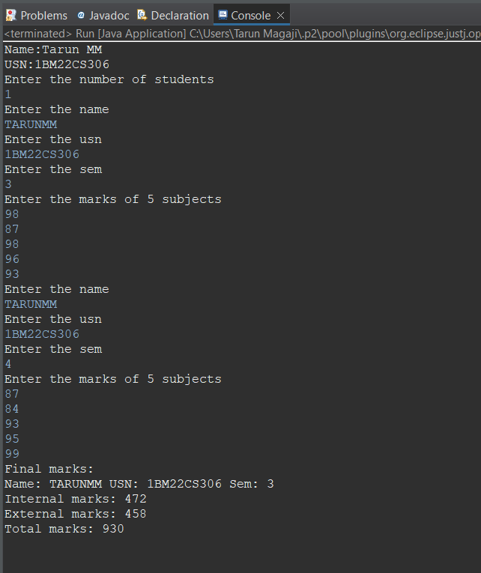

PROGRAM 7:

Write a program that demonstrates handling of exceptions in inheritance tree.

Create a base class called “Father” and derived class called “Son” which extends the

base class. In Father class, implement a constructor which takes the age and throws

the exception WrongAge( ) when the input age<0. In Son class, implement a

constructor that cases both father and son’s age and throws an exception if son’s age

is >father’s age.

class WrongAge extends Exception {  
    public WrongAge(String message) {  
        super(message);  
    }  
}  
  
class Father {  
   int age;  
  
    public Father(int age) throws WrongAge {  
        if (age < 0) {  
            throw new WrongAge("Age cannot be negative");  
        }  
        this.age = age;  
    }  
  
    public int getAge() {  
        return age;  
    }  
}  
class Son extends Father {  
     int sonAge;  
  
    public Son(int fatherAge, int sonAge) throws WrongAge {  
        super(fatherAge);  
        if (sonAge >= fatherAge) {  
            throw new WrongAge("Son's age cannot be greater than or equal to father's age");  
        }  
        this.sonAge = sonAge;  
    }  
  
    public int getSonAge() {  
        return sonAge;  
    }  
}  
  
public class Main {  
    public static void main(String[] args) {  
        try {

System.out.println("Name: TARUN MM");

System.out.println("USN: 1BM22CS306");  
            Father father = new Father(45);  
            System.out.println("Father's age: " + father.getAge());  
  
            Son son = new Son(45, 50); // This will throw an exception  
            System.out.println("Son's age: " + son.getSonAge());  
        }

catch (WrongAge e) {  
            System.out.println("Exception caught: " + e.getMessage());  
        }  
    }  
}

OUTPUT:

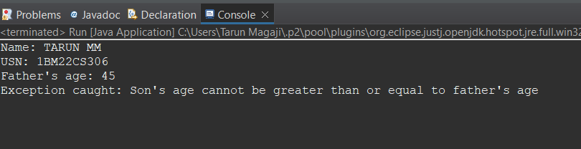

PROGRAM 8:

Write a program which creates two threads, one thread displaying “BMS College of

Engineering” once every ten seconds and another displaying “CSE” once every two

seconds.

class DispMessage extends Thread {  
    String message;  
   int interval; // Interval in milliseconds  
  
    public DispMessage(String message, int interval) {  
        this.message = message;  
        this.interval = interval;  
    }  
  
    public void run() {  
        while (true) {  
            System.out.println(message);  
            try {  
                Thread.sleep(interval);   
            } catch (InterruptedException e) {  
                e.printStackTrace();  
            }  
        }  
    }  
}  
public class Main {  
    public static void main(String[] args) {

System.out.println("Name: Tarun M M");

System.out.println("USN: 1BM22CS306");  
    DispMessage bmsThread = new DispMessage("BMS College of Engineering", 10000);   
    DispMessage cseThread = new DispMessage("CSE", 2000);   
  
    bmsThread.start();  
    cseThread.start();  
    }  
}

OUTPUT:

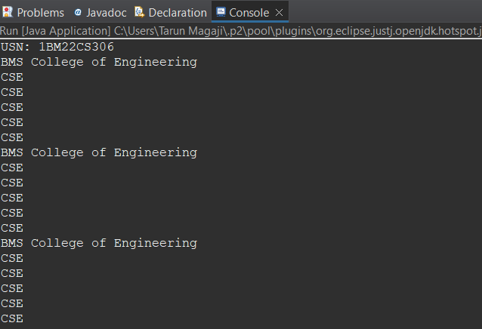

PROGRAM 9a:

Create a label, button and text field in a frame using AWT.

import java.awt.*;

import java.awt.event.*;

public class AWTExample extends WindowAdapter {

Frame f;

Label l;

Button b;

TextField t;

AWTExample() {

f = new Frame();

f.addWindowListener(this);

l = new Label("Employee id:");

b = new Button("Submit");

t = new TextField();

l.setBounds(20, 80, 80, 30);

t.setBounds(20, 100, 80, 30);

b.setBounds(100, 100, 80, 30);

f.add(b);

f.add(l);

f.add(t);

f.setSize(400, 300);

f.setTitle("Employee info");

f.setLayout(null);

f.setVisible(true);

}

public void windowClosing(WindowEvent e) {

System.exit(0);

}

public static void main(String[] args) {

AWTExample obj = new AWTExample();

}

}

PROGRAM 9b:

Create a button and add an action listener for mouse click.

import java.awt.*;

import java.awt.event.*;

public class EventHandling extends WindowAdapter implements ActionListener {

Frame f;

TextField tf;

EventHandling() {

// Create components

f = new Frame();

f.addWindowListener(this);

tf = new TextField();

tf.setBounds(60, 50, 170, 20);

Button b = new Button("Click me");

b.setBounds(100, 120, 80, 30);

// Register listener

b.addActionListener(this); // Passing current instance

// Add components and set size, layout, and visibility

f.add(b);

f.add(tf);

f.setSize(300, 300);

f.setLayout(null);

f.setVisible(true);

}

public void actionPerformed(ActionEvent e) {

tf.setText("Welcome");

}

public void windowClosing(WindowEvent e) {

System.exit(0);

}

public static void main(String[] args) {

new EventHandling();

}

}